**Special Project in Big Data and Art Forgery**

Here is some background on the relevance of this project. In summary, there is an enormous amount of money at stake and the expense of verify authentic artworks is expensive. There is a new way to use Artificial Intelligence and Big Data to authenticate artwork (or at least identify fraud) but that too is beyond the reach of the average Introduction to Art student. In this project, you will get a chance to practice some of this work at an inexpensive and approachable level.

**The Money In Art**

The global art market value decreased significantly in 2020 over the previous year, due to the impact of the coronavirus (COVID-19) pandemic. Art and antique sales value worldwide amounted to over 64 billion U.S. dollars in 2019. In 2020, the global art market value dropped to roughly 50 billion U.S. dollars, experiencing a 22 percent decrease.

Published by [**Statista Research Department**](https://www.statista.com/statistics/883755/global-art-market-value/)

50 billion dollars is twice Australia's Gross National Product (GNP) or more than

the top publicly traded companies (profit) in the world.

Published by [Forbes](https://www.forbes.com/lists/global2000/#20562ae05ac0)

With that much money at stake, there are bound to be some criminals that want a piece of the"action."

**Criminal Activity**

Art crimes can include theft and fraud. Twenty-eight years ago, two men dressed as policemen forced their way into Boston’s **Isabella Stewart Gardner Museum** and stole half a billion dollars’ worth of art. To this day, it’s the largest art heist ever committed— and it remains unsolved. Theft can include patience in "casing" the museum or gallery, authentic "wardrobe", guns and hostages, and the difficulty in trying to "re-sell" the stolen artwork as it will be a well-communicated and one-of-a-kind object. An easier process is FRAUD.

The 6 Most Common Art Frauds involve:

1. creation of fake art - by individual artists.

2. large scale manufacture of fake art - on an industrial scale.

3. creation of fake art materials.

4. art galleries / fairs trading while insolvent.

5. money laundering when purchasing art.

6. money laundering via art market sales and auctions

In this project we will concentrate on #1. **creation of fake art - by individual artists or FORGERY.**

Art forgery is a divisive topic that inspires awe and anger in equal measure. While galleries, dealers collectors certainly don’t want fakes on their hands, it’s hard not to be impressed by painters who can imitate the greats so believably. Even with all the technology designed to verify artworks, there are still lots of convincing fakes still on display in museums around the world.

For each of the major (dead) artists whose works sell for millions of dollars, there are one or two experts (sometimes related to the artist) who have the authority to issue certificates of authenticity or to deem the works worthy of further study. The basis for these judgments can sound surprisingly touchy-feely, involving words like "energy" or "it didn't speak to me." The experts say that this intuitive reaction is supported by a deep knowledge of the artist's materials, brushwork, color palette—even whether he or she was right- or left-handed. Though there have been cases of expert-authenticated works later proved to be fakes, there have also been cases of experts catching mistakes forensic tests missed.

**One of the Simplest Techniques to Analyze Fakes: Left-Hand/Right-Hand Analysis**

Martin Kemp looked closely at the shading—it seemed to have been drawn with a left hand, just as Leonardo had done.

Not only had the drawing apparently been done with left-handed strokes; the artist, like Leonardo, had relied on the palm of his hand as a way of softening the shading.

Martin Kemp made a habit of cataloguing the mistakes of Leonardo’s imitators and forgers: an inadvertent right-handed brushstroke: <https://www.newyorker.com/magazine/2010/07/12/the-mark-of-a-masterpiece>

**What We Can Do**

80,000 stokes analysis is more than we can accomplish in our smaller project. But we can learn something about using data to detect art forgeries. We can analyze left-handed and right handed artists and see if we can spot a forgery. Left-handed artists usually make marks from the upper left to lower right. Right-handed artists usually make marks from the upper right to lower left. This is because of the natural movement of the fingers, wrist and arm to **swing** away from the body rather than **jab** forward and back. See the arrows below on the two examples. Try it yourself on a scrap piece of paper. Do your marks swing or jab?

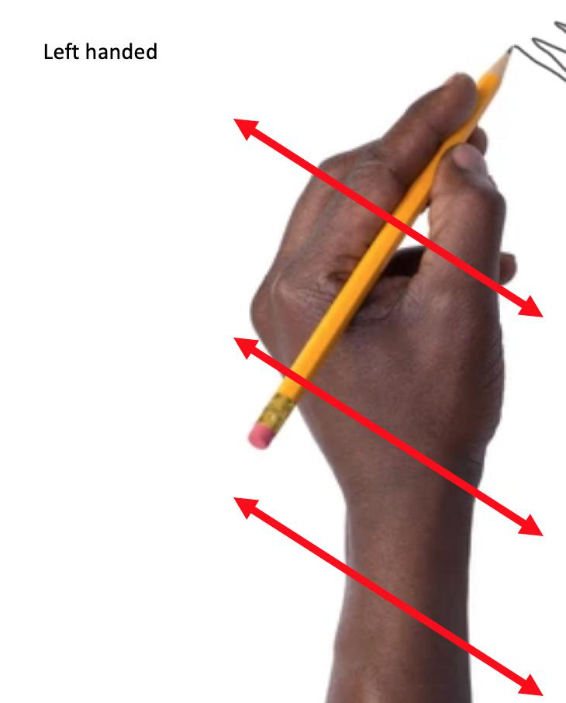

**How We Will Do It**

Let’s take a very simple example of upper left to lower right or upper right to lower left line drawing.

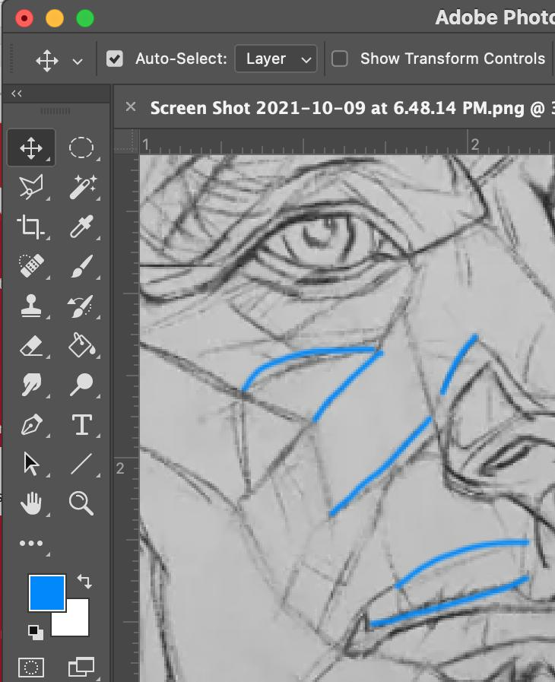\

If we open the "info" window in Photoshop, we can place the cursor (I have exaggerated these as large dots to see them easier) over drawing lines- such as the blue line beside the nose and see x and y values in the info window in the upper right of the screen. First find the beginning of the line and then find the end of the line.

We can look at other lines as well. Below we can map the X and Y of the red line.

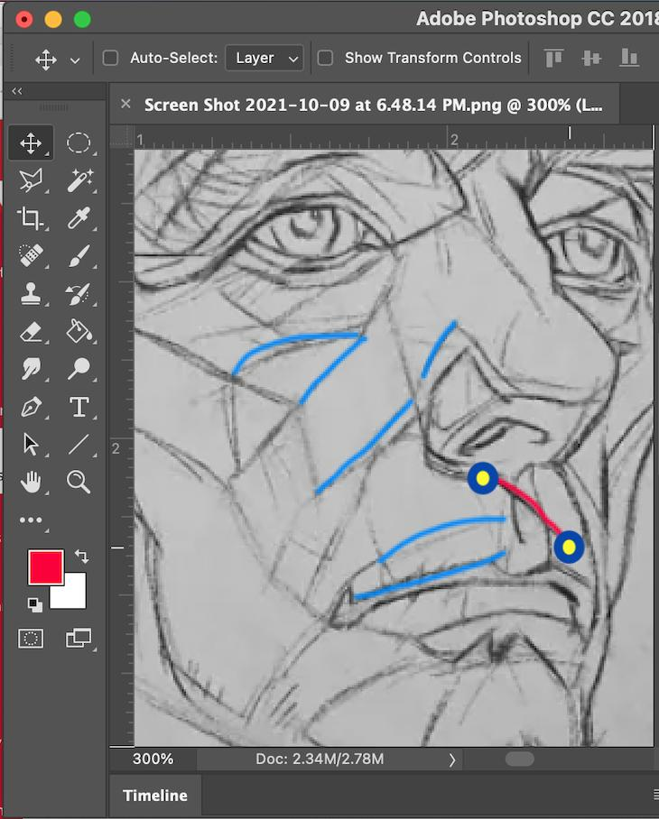

**The Blue line showed us these coordinates:**

beginning point



end point



**The Red line showed us these coordinates:**

beginning point

end point

**If we take this to Excel, we can record it like this:**

You can see where the x and y coordinates go and then I have formulated the sheet to automatically compute SLOPE, DEGREE, and HANDEDNESS (1=Right hand and 0= Left hand)

**Here is the artwork to test:**

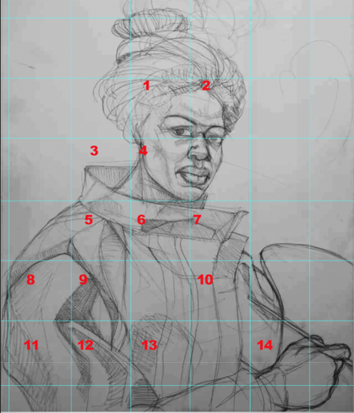

x and y coordinates of the above image go into BLUE cells on the spreadsheet.

x and y coordinates of the above image go into RED cells on the spreadsheet.

One of these is a fraud. While it is almost impossible to prove the authentic drawing, you can be very persuasive in using your data to argue that one is the imposter. Students in this project have been listed in numbered alphabetical order. Quadrants have been created over each drawing. The number next to your name relates to your numbered quadrant. We will make the gathering of data easier by dividing the workload from all the students. You will be responsible for 30 lines in your quadrant from each drawing. The instructor will provide a formatted excel sheet that will automatically generate Slope, Degree and "Handedness" with 0 suggesting left-handedness and 1 suggesting right-handedness. The artist, Kerry James Marshall, is left-handed. The imposter is right-handed.

When you have completed your collective 60 lines, you will send to me to combine into a "group-sized" excel file. Your final responsibility is to analyze the group file and report to me which is the fraud, and which is authentic.

The instructor will prepare the excel sheet but you have to do the sleuthing to find lines to analyze. The line data will go into a spread sheet such as the illustration below:

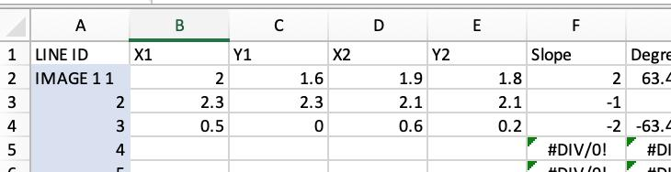

The formula for the SLOPE column is simply =-(E2-C2)/(D2-B2), the formula for Degree is =-DEGREES(ATAN((E2-C2)/(D2-B2))). Assuming that taking whether the slope is negative or positive is sufficient, that formula is =IF(G2<0, 0, 1).